Wootton Bassett Infants’ School
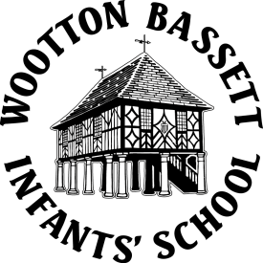
High Street
Royal Wootton Bassett
Wiltshire
SN4 7BS
Tel: 01793 852254
Head Teacher - Mark Hazzard

admin@woottonbassett-inf.wilts.sch.uk
Website: www.woottonbassett-inf.wilts.sch.uk

Wednesday, 02 October 2019
Dear Parent/Carer,

Pupil Premium

Our school receives considerable extra funding for children who are entitled to free school meals. In an infants’ school where the children all receive a free school meal anyway, there is less incentive to apply to be eligible for free school meals. However, if a child is eligible for free school meals, parents are not expected to pay for school trips or to contribute if we have visitors in the school such as a puppet show. These can all be covered by the contribution we receive as pupil premium. Your child will also be eligible for free school milk after their fifth birthday.

If you think your child may be eligible for pupil premium (if you are on Income Support, Job Seekers Allowance, Income Related Employment and Support Allowance, Support from the National Asylum Support Service, the guarantee of State Pension Credit, Child Tax Credit with an income of no more than £16,190, Working Tax Credit run-on or Universal Credit), please fill in the attached form. If you need any help at all filling in the form please do not hesitate to contact Miss Lynne at the school office.

Yours sincerely

Mark Hazzard

Mark Hazzard
Headteacher

